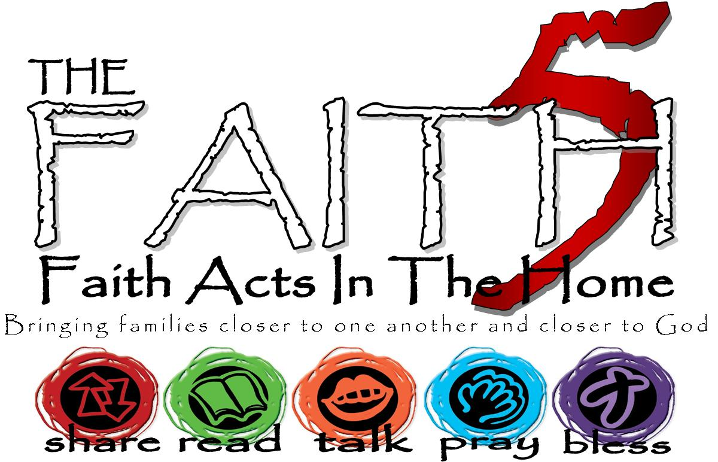
St. Daniel’s Lutheran
Fall 2017
Grow In Faith Together
GIFT
Week #1
Sunday | 17-Sep | Week 1: The theme of this week is: that we are saved by faith.
Monday | 18-Sep |  | Romans 1:16-17
Tuesday | 19-Sep |  | Habakkuk 2:1-4
Wednesday | 20-Sep |  | *
Thursday | 21-Sep |  | Romans 1:8-17
Friday | 22-Sep |  | Stacker MTWI | see who can stack most nuts/cereal pieces one-on-top-of-another
Saturday | 23-Sep |  | John 16:29-33
MTWI – Minute-To-Win-It… a silly game, meant to be played for 1 minute. Have a great time!
Write some of your highs and lows from the week here…

*A weekly hands-on activity or event of your choosing to be recorded on your sheet, with a simple summary (Where, what, outcome for other(s) and you):
Ie. This week we went to Berks Heim to worship with the residents. I made someone smile when I smiled at them! It made me feel good to share God’s love that way.

