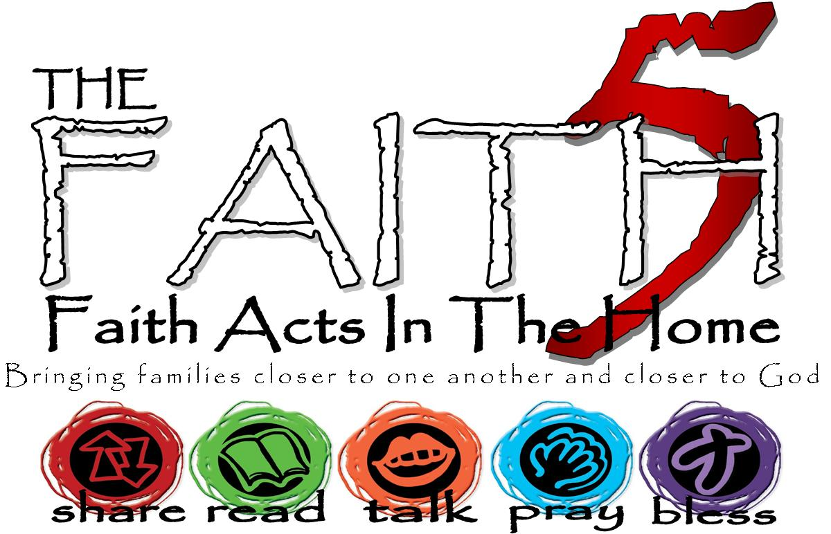
St. Daniel’s Lutheran
Fall 2017
Grow In Faith Together
GIFT
Week #4
Sunday | 8-Oct | Week 4: Grace Alone. Salvation is a gift of God, and so the theme is grace.
Monday | 9-Oct |  | Ephesians 2:8
Tuesday | 10-Oct |  | Isaiah 53
Wednesday | 11-Oct
Thursday | 12-Oct |  | Psalm 130
Friday | 13-Oct |  | Breakfast Scramble MTWI | Cut front of cereal box into 20 equal squares. Solve the resulting puzzle in 1 min to win.
Saturday | 14-Oct |  | Ephesians 2:1-8

Write some of your highs and lows from the week here…

