UNITY IS A LAW, LIKE THE LAW OF GRAVITY IT WORKS!!!

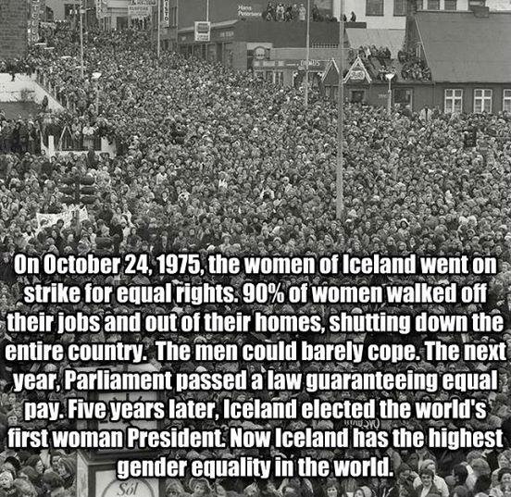
'International Women's Day History: On Oct. 24, 1975, 90% of Icelandic women went on strike, refusing to do any work at their homes or their jobs. It was the largest demonstration in the nation's history and shut down the entire country. Airports were closed, schools were closed, and hospitals couldn't function. The strike had an immediate and lasting impact. The following year, Iceland's Parliament (now half women) passed a law guaranteeing women equal pay and paid maternity leave. Four years later, Iceland elected the world's first female President. And today, Iceland has the highest gender equality in the world. If you support equality, LIKE our page @[186219261412563:274:US Uncut]!! http://bit.ly/1Etu1hO'

