Join us as we
fight for
MARRIAGES!

MARRIAGE MENTOR
TRAINING
PROVIDED BY DARE TO BE DIFFERENT IN PARTNERSHIP WITH LOVE AND RESPECT

COUPLES
HELPING
COUPLES

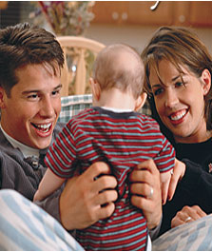

Thousands of mentors
have been trained,
making a difference
one family at a time.

Trained mentors will be equipped to help couples
find real healing and a restored relationship!

DATE:

Where:

When:

Cost: To be determined by the church
Includes training materials, food and beverages

TO REGISTER CALL:

