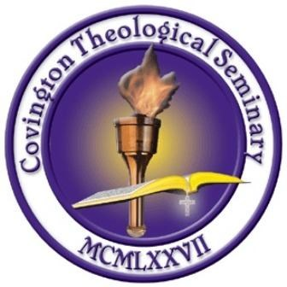

**NORTHWEST SC**

**2015 Spring Schedule**

**Easley, SC**

# Tuesday 8:30 AM

**TH-350 Creation Theology *Text – Battle for the Beginning by MacArthur* Kevin Dennis**

**Tuesday 10:55 AM**

**PS-535 Pastoral Theology II *Text – Between Two Worlds by Stott* Dr. Matt Danuser**

**Tuesday 6:00 PM**

**PS-428B The Cults II *Text—Kingdom of the Cults by Martin* Dr. Alton Nix**

# Tuesday 8:20PM

**BI-482 The Apostle Paul *Text—Paul-Apostle of the Heart Set Free by Bruce* Jeremy Merck**

# Thursday 6:00 PM

**BC-500 Biblical Counseling Survey *Text –The Christian Counselor’s Manual by Adams* Dr. Sam Byrum**

**BI-192 1 Timothy *Text- The Message of 1 Timothy/Titus by Stott*  Dr. Tom Hayes**

## Thursday 8:20 PM

## TH-503B Eschatology II *Text –Things to Come by Pentecost* Ron Humphries